Diagnostic Services Requesting & Reporting Design Project (DSRRD)

Expected Sender & Receiver Systems Functionality

Domain: Pathology

Amendment History:

Ver | Author | Date | Amendment History
0.1 |  | 17/10/2005 | First formal draft for comment
0.2 |  | 07/11/2005 | Amended following review
0.3 |  | 23/11/2005 | Amended following internal review
0.4 |  | 01/12/2005 | Amended following internal review
0.5 |  | 04/12/2005 | Amended following internal review
0.6 |  | 06/12/05 | Amended following internal review
0.7 |  | 16/01/2006 | Amended following review (up to and including 5.1 Requester Systems only) by Path Review Group
0.10 |  | 22/02/2006 | Amended following full review

Reviewers:
This document must be reviewed by the following. Indicate any delegation for sign off.
Name | Signature | Title / Responsibility | Date of Issue | Version
Sally Stanley |  | DSRRD Project Manager |  | 0.10
Simon Withey |  | DSRRD Design Lead |  | 0.10
Peter Otter |  | DSRRD Business Analyst |  | 0.10

Approvals:
This document requires the following approvals.

Name | Signature | Title | Date of Issue | Version
Ross Dixon |  | Senior Business Architect |  | 0.10
Phil Clayton |  | Programme Manager |  | 0.10
Ken Lunn |  | Head of Message Development |  | 0.10

Document Location
This document is only valid on the day it was printed. Please contact the Document Controller for location details or printing problems.

This is a controlled document.
On receipt of a new version, please destroy all previous versions (unless a specified earlier version is in use throughout the project).

© Crown Copyright 2005

Unauthorised copying, distribution, renting, lending or communicating to the public of all or a substantial part of any Crown Copyright material is prohibited. Licences for the use of Crown Copyright material are available from Her Majesty's Stationery Office, at http://www.hmso.gov.uk (click on 'Click-Use licences').

All trade marks and logos are the property of their respective owners. The use of any trade mark or logo without the prior written permission of the relevant owner is prohibited.

Related Documents.

These documents will provide additional information.

Ref. no. | Doc Reference Number | Title | Version
1 | NPFIT-SHR-QMS-PRP-0015 | Glossary of Terms Consolidated.doc
2 | NPFIT-SHR-MODL-PMLLAB-0013.06 | Pathology Primary Care Requesting and Reporting Detailed excluding PSIS | 0.8
3 | NPFIT-SHR-MODL-PMLLAB-0021.02 | Pathology Secondary Care Requesting and Reporting Detailed excluding PSIS | 0.3
4 | NPFIT-SHR-MODL-PMLLAB-0011.11 | W5 Communication definition for Pathology.doc | 1.0
5 | NPFIT-SHR-MODL-PMLLAB-0025.02 | Publishing Request Message Configurations | 0.5
6 | NPFIT-PRI-GMP-DPM-0378.01 | Principles for carrying Pathology Request and Results data as SnCT concepts | 0 8
7 | NPFIT-SHR-MODL-PMLLAB-0004.10 | Pathology Primary Care Requesting and Reporting Scoping Document without PSIS | 0.9
8 | NPFIT-SHR-MODL-PMLLAB-0035.02 | Pathology Secondary Care Requesting and Reporting Scoping Document without PSIS | 0.2
9 | NPFIT-FNT-TO-DPM-0311.02 | SNOMED CT Post Coordination rules Guidance Document | 1.0
10 | NPFIT-FNT-TO-DPM-0491.01 | Message Information Manual | 5.0

Glossary of Terms.

Term | Definition
Clinical Workstation | An IT system used by a healthcare staff member at his or her place of work.
Laboratory Information Management System (LIMS) | An IT System which supports the management processes of a Pathology Service Provider. The main functions of the LIMS include, interfaces to automated analysers, automated calculation of parameters, scheduling, via work lists for example and the storage of all results, including the clinical interpretation(s) of the investigations performed.
Haematology | The haematology department is concerned with the morphology and physiology of blood, using automated instruments to count blood cells & haemoglobin levels, which aids the diagnosis and treatment of diseases such as anaemia and leukaemia.  Blood smears are made of abnormal counts to examine the cell types and the appearance of the blood by microscopy to help to diagnose illness or the progression of treatment. White blood cells are identified and classified to aid diagnosis of leukaemia.  Another important area is the study of abnormalities of blood coagulation. Coagulation (blood clotting) measures the ability of the blood to clot, either as a check before surgery, patients who have unexplained bleeds, or monitoring patients on anticoagulants like warfarin & heparin.
Clinical Chemistry | Clinical chemistry (also known as biochemistry or chemical pathology) is the study of chemical and biochemical mechanisms of the body in relation to disease, mostly through the analysis of body fluids such as blood or urine. In many diseases there are significant changes in the chemical composition of body fluids such as the raised blood enzymes due to their release from heart muscles after a heart attack; or a raised blood sugar in diabetes mellitus due to lack of insulin. Investigations are designed to detect these changes qualitatively or quantitatively compared to results from healthy people.
Cellular Pathology | The histopathology department receives tissue specimens from patients, taken at either surgical operations or post-mortem examination. Diseases such as cancer are diagnosed by looking for abnormal features in tissue cells. The specimens are processed and thin sections cut and stained for microscopical examination to determine the underlying disease process. Tissue is processed to paraffin wax (about 15 hours and usually carried out overnight), and a wax block made of the tissue. From this block, tissue sections (about 3 microns) are cut and stained, so that cellular structures and details can be visualised microscopically. Further staining techniques may be required to identify a tissue component not readily seen in the first section, for example a micro organism such as TB. Other specialised techniques such as immunocytochemistry can be used to identify a tumour or variant of a tumour. Very rapid results (within minutes) can be obtained by freezing the tissue and cutting sections in a refrigerated cabinet (a cryostat), often used when the patient is still in the operating theatre.  Cytology is the study of cells, and is best known for its role within the National Cervical Screening Programme and the microscopical detection of pre-malignant changes within the cells taken from the cervix (neck of the womb) on stained slides. Also involved is the processing of specimens from any site where cells can be obtained without surgery: these include sputum & bronchial washings/ brushings, urine, fluid from body cavities and cysts and fine needle aspiration (FNA) from lumps - e.g. breast lumps.
Microbiology | Microbiology is concerned with the detection, isolation and identification of micro-organisms such as bacteria, fungi and parasites that cause disease. Any part of the human body, whether tissue or fluid, can be examined. Urinary Tract Infections are by far the most common infection in the UK, and as a consequence, urine samples are the most common sample examined. Samples, which often arrive as fluid or swabs from various orifices, are inoculated onto culture media which allows the micro-organisms to grow after overnight incubation, usually at body temperature (37°C). The following morning the culture plates are examined and interpreted to determine whether any of the organisms growing is a pathogen or not. Virology is the study of viruses and the diseases caused by them such as German measles, HIV and Chickenpox. It is also involved in monitoring the effects of vaccines
Micro organism | A microscopic organism, those of medical interest include bacteria, viruses, algae, fungi and protozoa. May also be shortened (within a microbiology context) to organism.
Analytical Investigation | Usually shortened (within a pathology context) to investigation. The process of examining or testing a sample to assist in the clinical diagnosis or monitoring of disease states. Most can be requested by a clinician but some will be only reported as part of a battery, or will be performed in response to the results of previous investigations or a specific clinical history.
Clinical Investigation | A clinician may request a number of investigations or batteries, from various pathology disciplines in order to investigate a specific clinical condition, for example shortness of breath or anaemia.
Test | Synonymous with analytical investigation and in some circumstances is preferable, for example Pregnancy Test. However some disciplines don’t perform tests (Histopathology for example) and so, when referring to generic pathology, the term investigation has been used throughout.
Battery | A battery is a group name for a number of investigations reported together. For example a request for a full blood count will be reported with usually at least twelve individual investigations (some of which can’t be requested by a clinician).
Isolate | An isolate, used in the context of this document, is any organism present in the specimen that has been observed and identified to at least generic level.
Specimen centric report | This is the usual form of reporting with a number of investigations being performed on one sample. There may sometimes be more than sample for example Urea & Electrolytes including Glucose will require a two samples to preserve the glucose level but they are obtained during the same act of phlebotomy.
Investigation centric report | This is a report on a number of samples with one requested investigation. The samples may be taken at different times and sent to the laboratory individually or together. The report will usually consist of individual investigations with results for each specimen and will often contain a summary comment. Examples of investigation centric reports are: Glucose Tolerance Test (GTT). Methicillin Resistant Staphylococcus aureus) MRSA screen, Creatinine Clearance.
Aborted status | There are many reasons why individual investigations or even a complete sample won’t be processed by the laboratory; insufficient or incorrect sample merely being the most common. In these instances the laboratory will enter a status of ‘aborted’ at the level of investigation or battery and issue a report to fulfil the request and allow the requester to repeat, if so desired.  However, on reviewing any historic reports within the clinical system, it is expected that these investigations or batteries with a status of aborted (which contain no useful clinical results) can be suppressed from the normal view.
Report | A report is issued from the fulfilling laboratory in response to a valid request from a clinician and contains the results of the performed investigations and any relevant technical and clinical guidance.  A single request may be fulfilled by more than one report and, conversely, a number of requests may be combined into one report.  The style of report will vary between the disciplines; the blood sciences producing largely numeric results and histopathology producing textual and verbose reports.
TMS | Transaction and Messaging Spine The message handling application element of the Spine.
LRS | Legitimate Relationship Service A connection to a patient that may justify access to the patient’s sensitive Personal Data.
PSIS | Personal Spine Information Services Personal Spine Information Services are person-based services designed to help ensure the integrity of the care to individuals. Each person has common information, a summary of their health record held on the Spine, that is used by care providers to assist in providing for their healthcare and is the enduring system of record for key information on an individuals care. The Personal Spine Information Services comprise two functional areas, a health record service and a care delivery service.
SDS | Spine Directory Service A directory service for the National Programme Spine.

Contents

1. Contents 6
2. Purpose of this Document 7
3. General Requirements 7
4. Planned Pathology Communication Flows 8
4.1. Requesting 8
4.2. Reporting 9
5. System Specific Functionality Expectations 9
5.1. Requester systems 9
5.1.1. When Requesting: 9
5.1.2. When Receiving Pathology Reports: 11
5.2. Service Provider (LIMS) Systems: 12
5.2.1. General: 12
APPENDIX 13
1. Pathology Report Status 13
1.1. Storyboards 13
1.1.1. Storyboard 1 13
1.1.2. Storyboard 2 14
1.1.3. Storyboard 3 14
1.1.4. Storyboard 4 15
1.2. Status Management 16

Purpose of this Document

This document details the expected receiver and sender system functionality to inform suppliers when implementing Pathology communications. It should be read in conjunction with:
- The Pathology Business Process Model documentation (Refs. # 2 & 3 above),
- Pathology Primary Care Requesting and Reporting Scoping Document without PSIS (Ref. # 7 above)
- Pathology Secondary Care Requesting and Reporting Scoping Document without PSIS (Ref. # 8 above)
- The Pathology Reporting Business Communication Specification W5 (Ref. # 6 above).
- MiM v5.0 (Ref. #10 above)

It is not a system specification but a guide to the expected functionality that will be required in order to implement Pathology Stage 1 communications scope. As such it does not deal with “normal” LIMS and end clinical systems functionality but concentrates on new or amended functional requirements concerned with receipt, processing and generation of information sets to support NHS Connecting for Health Pathology communications. Note that it does not include generic message parsing or transportation service related functionality.

It will be expanded to coincide with later releases of the MiM and will incorporate future stages of message development and their corresponding impact on expected functionality.

Note, this document must be read in conjunction with the W5 (Ref #4, above) which contains full detail on the use and display of presentation text reports.

General Requirements
The following are general guidelines for provider and end user systems.

No | General Requirements
 | Primary and Secondary Care patient record and requesting systems, and Pathology Service Provider Laboratory Information Management Systems (LIMS) shall be NHS Connecting for Health compliant with all builds from 2007A of TMS, LRS, PSIS, SDS and PDS connectivity. (or from a local demographic system with PDS compliance)
 | All systems should employ those elements of a Common User Interface (currently in development) that are relevant to pathology in order to minimise the need to repeat data entry across interfaced functions, thus reducing the time required to populate these complex message structures (i.e. one-time data capture/entry, intelligent coding of text entry, minimal drop-down lists, etc)
Requesting systems shall provide Decision Support mechanisms to assist the clinician to request appropriate and timely pathology investigations based on local clinical and contractual arrangements.

Equivalent laboratory system function shall allow interpretation of requested items based upon on local clinical and contractual arrangements
Pathology Service Provider LIMS shall provide at least a single Pathology Report to fulfil requests received and performed in part or whole.

The report(s) shall be sent by the Pathology Service Provider to the original requester’s system (placer system), and to any nominated report recipients.

Note: Although there is an expectation of full electronic messaging in the future, support for current paper report production will need to be provided under some circumstances. Support will also be required for receipt of paper requests and issuing of electronic reports.

 | Where coded values (primarily SNOMED CT (SnCT), see Ref #6, above) have been used within any communication, all viewer systems shall translate these into the clear text so that the user can read either the SnCT preferred term or a locally agreed term, in its proper context.
An investigation or battery may be marked as aborted and a report may have all its constituent investigations or batteries aborted and thus contain no useful clinical information. It is end system functionality to note the aborted status at the appropriate level so that results can be hidden from the end user.

The effect of the aborted status is purely for listing of historical results and doesn’t affect the clinical review of received reports. End systems will be required to allow viewing of report histories containing all results or be able to filter out and suppress the aborted results.

Planned Pathology Communication Flows

Requesting
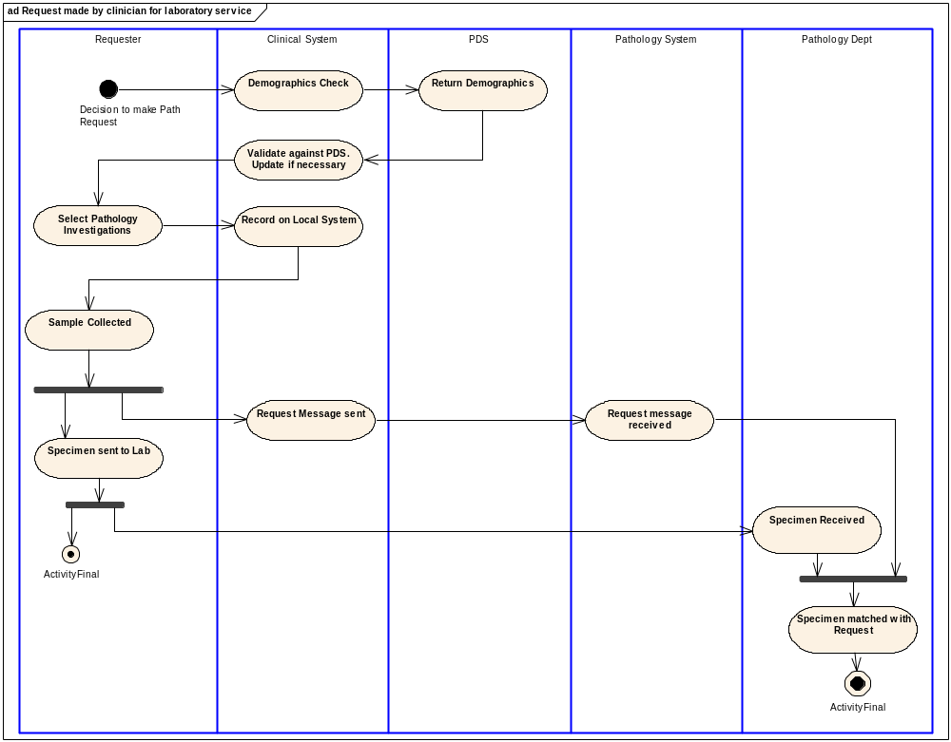

Reporting
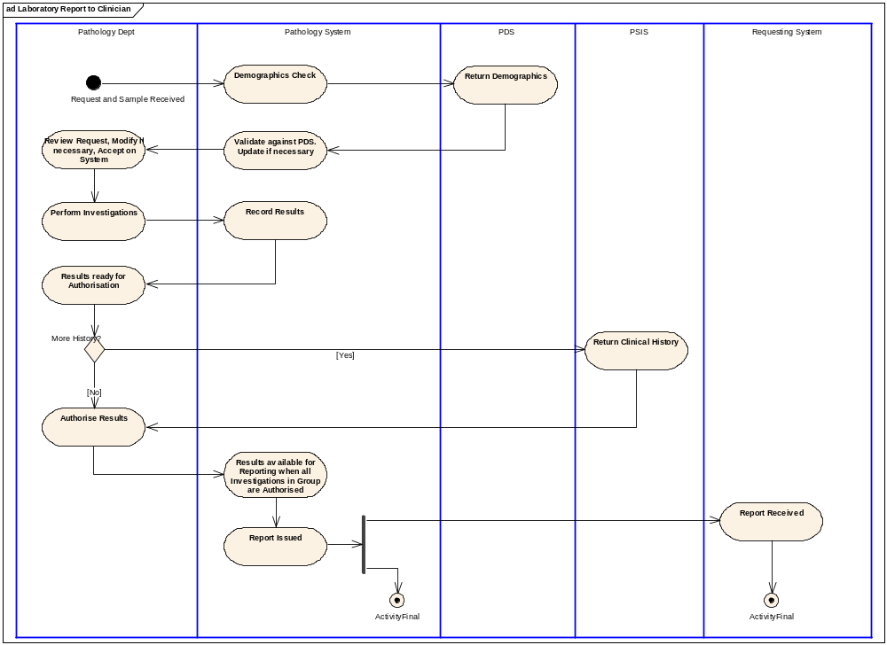
For further information see Business Process Models (Refs. # 2 & 3 above)

System Specific Functionality Expectations

Requester systems

When Requesting:

Requesting Systems shall:

No. | Expected Functionality
- 2 | Allocate human readable Placer Request IDs to whole request communication instances.
Use the National Catalogue to identify investigations within Pathology Request communications.

Make full use of user friendly pick lists, including locally agreed terms, to assist users in rapidly identifying suitable procedures, i.e. “FBC”. However, requesters shall have the national catalogue preferred or synonym terms displayed to them for selection/confirmation.
 | Allow the requester decide to which Pathology Service Provider they wish to send the request, picked from a list of known service contractors that provide the required investigation(s), with functionality for a default Service Provider and ability to over-ride the default.
 | Provide functionality to maintain details of specimen requirements for each investigation provided by laboratories.
 | Estimate and confirm the number of samples required in order to generate the correct number of labels, and identify each sample within the message.
- 4 | Print a combination of tokens and appropriate specimen labels to support the process of obtaining the required samples from, or by, the patient. See ICRS OBS Part_2_LSP_services 102.10.3 (Full bar-coding functionality shall be supported, including the provision of barcoded wristbands and production of barcodes on patient letters, appointment cards, and all labels and prints.)
 | Include the priority status of the investigation(s) on the request token so that, for example, a request is marked as Urgent
- 5 | Support the audit and management of investigation request communications, including error reports.
 | Enable the creation of new requests using information contained in previous requests.
- 6 | Facilitate the selection and inclusion of information from the patient’s medical record into the Pathology Request communication; mechanisms may include user selection and/or prompted information content such as current clinical history.  For example: When Microbiology investigations have been requested, any prescription should be issued first and the request module can check for prescriptions issued within a user defined period, say the previous 30 minutes, and pre-populate the request with Proposed Medication. If the prescription was issued more than 30 minutes ago it can be used to pre-populate Actual Medication.
- 8 | Not require the clinician to repeat data entry of supporting information when completing a number of requests .
 | Provide decision support with regard to recently placed requests
- 12 | Be able to create and route separate Request communications, as required, to the correctly identified receiving system.  For example: If a Pathology Service Provider has identified one LIMS for certain disciplines (e.g. Haematology & Biochemistry) and another LIMS for other disciplines (e.g. Microbiology and Histopathology), the request communication(s) must be sent to that system which is relevant to the investigation(s) requested.
- 13 | Provide a means for the requester to complete discipline, or investigation, specific questionnaires. These should be automatically prompted when one or more investigations (previously defined by the recipient laboratory) are requested. The questionnaire answers should be in the form of SNOMED CT codes which contain the question and its resultant answer.  For example:  A request for malaria screening test will prompt for details of travel abroad and dates of return to the UK.  A request for a Cytology smear will prompt the user for specific clinical information and include appropriate SnCT codes compliant with the responses.
- 15 | Provide a practical way for Requesting systems to intelligently prompt for post coordinated investigation terms if a common pre coordinated term isn't available, and follow the principles embodied in Ref. #9 above
- 16 | Provide a user friendly system to allow copy reports to be requested for clinicians and practices outside the normal healthcare community boundaries.  For example a clinician in Newcastle may wish a copy report to be sent to the patient’s GP in Bristol, and therefore must be able to easily identify the ‘copy to’ recipient and enter relevant details for inclusion within the single request communication.
 | Use the ethnicity as recorded within the clinical system, utilising the HES 16 + 1 categories, to populate the Ethnic Derivation data item in the request communication until the requirements for ethnic derivation in specifying reference ranges have been defined.

When Receiving Pathology Reports:

Requesting Systems shall on receiving Pathology Reports:

No. | Expected Functionality
- 1 | Be able to receive and process the Pathology Report communication even if they are only the ‘copied to’ receiver.
- 2 | Display reports appropriately with due regard to their differing priority codes.  For example, notify the requesting clinician, or their proxy, when a pathology report having an ‘Urgent’ status is received.
Make it possible for clinicians to reconcile the received Pathology Report communications with their original requests, utilising the status information provided in the Pathology Report communication(s). If a lab does not fulfil a requested investigation in a report with a status of complete then this shall be clearly identified by the system. “What is outstanding for this patient?” and if outstanding, is there more to come?

Note: The Pathology Report message shall carry the provider’s report status It is the requesting system’s responsibility to check this status against that of the original request. If the received provider’s report status is ‘complete’ and the requesting system (or user) agrees, it should change its own request status to ‘complete’ (or equivalent).
See Appendix and MiM (Ref. #10 above) for fuller details.
- 3 | Maintain an audit trail of historical reports when a pathology report is updated by the receipt of an amended report.  Note: Clinical decisions shall be traceable to the Pathology Report information available at the time the clinical decision was made.
- 4 | Not allow the requester to alter the content of received Pathology Reports, although they shall be able to add comments.
- 5 | Compare sex and date of birth within the report, as used as basis for interpretation, to the receiving system’s values, and if different, highlight those differences to the viewing clinician; otherwise this structured information need not to be displayed.  Note: The receiving clinical system will always display the patient demographics as a header outside of the report view and so report demographics are not required.
- 6 | Adhere to any national rendering rules and presentation text guidelines (as contained in the W5 see Ref. #4, above) when displaying received Pathology Reports.
- 8 | Allow the creation of rules in order to route the report to the correct individual for review. This may be the intended recipient on the report or their proxy.  For example trainee GPs may be mentored for a probationary period and reports may be initially reviewed by a senior partner.
Display the presentation textual report as the primary view of a report.

This initial viewing of the received report requires the entire report to be reviewed, commented upon and action assigned, as appropriate. However, subsequent review of the patient’s clinical history may involve a subset, or headline list, of key elements obtained from the structured items within the communication and not require this entire presentation text report.
 | Allow comments to be placed against the entire presentational report as well as against the structured items.
 | Incorporate the structured information into the clinical record to enable efficient and user friendly reviews of the patient’s history including graphing and trend analysis.
 | Support different work flow for an inbox where a report contains only aborted investigations; so the user knows that the investigation(s) need to be re-scheduled and re-submitted. However the system shall still require the report to be viewed but it may be in a different work flow context
 | Shall suppress aborted results (and reports containing only aborted results) from the default consultation and historic views; but allow the information to be displayed, if required

Service Provider Systems:

General:

Service Provider systems shall:

No. | Expected Functionality
- 2 | Have the facility to record details received on paper requests, including any Placer Request IDs supplied by the requester.
- 4 | Provide a user friendly system to allow copy reports to be designated for clinicians and practices outside the normal healthcare boundaries.  Provide a means for laboratories to look up and allocate details of copy recipients (where manual request received).  For example:  A clinician in Newcastle may wish a copy report to be sent to the patient’s GP in Bristol, and the system shall allow the correct identification of recipient details in a user friendly manner to satisfy that requirement.
- 6 | Identify, record and report those Pathology batteries or investigations that have been aborted, with reasons.  LIMS systems output must allow differentiation of investigations with and without results. In practice this means a sample with an aborted status would confer that status to any batteries and/or investigations held against that specimen. Similarly a battery with an aborted status would confer that status to any investigations within that battery.
- 7 | Provide a sophisticated mapping functionality to match local codes to the National Catalogue subset (SNOMED CT) for the purposes of creating reports.
- 8 | Be able to route received Pathology requests to the appropriate department/discipline/site.
 | Provide the ability for the LIMS to utilise the NHS number on receipt of an electronic request, automatically check the demographic details on the PDS service (or a PDS enabled PAS) and enter/update the demographic details on the LIMS
- 12 | Provide support for the sending of copy reports to registries based on disease hierarchies (cancer and renal hierarchy)  For example:  Be able to automatically send a copy report to the local Cancer Registry if a Histopathology report contains the SNOMED CT code ‘46732000’; this code is part of the malignant neoplastic disease hierarchy ‘363346000’.
 | The system must allow the fulfiller to indicate whether any isolates from the specimen should be included in the structured isolate section. Any named positive isolate shall be carried in the Isolate section if it is considered (by the fulfiller) to be significant.

